TURF FIRELOGS TIMBER
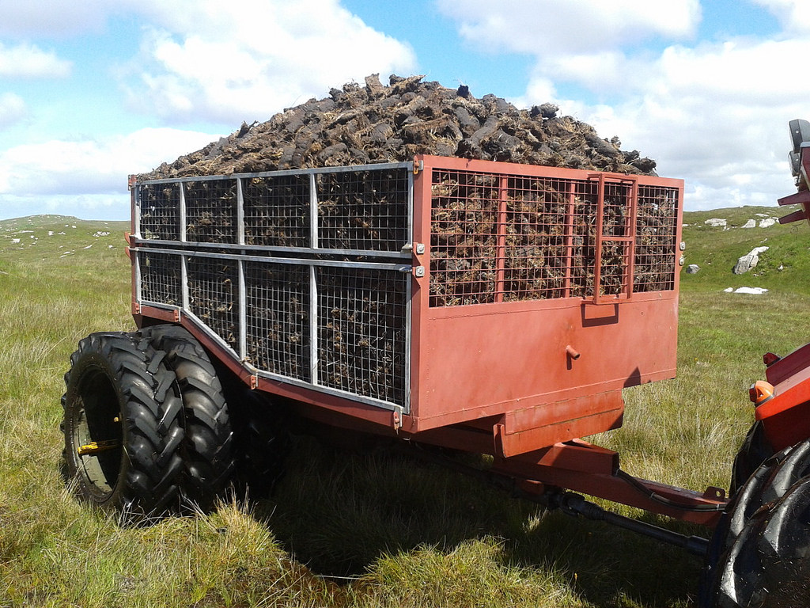
High quality turf, timber and homemade long-burning fire logs for sale as part of the Student Enterprise Awards. AVAILABLE FOR DELIVERY.
PRICES
Bag of Turf: €3.50
3 Bags of Turf for €10
Bag of Timber: €5
3 Bags of Timber for €12
3 Fire logs for €3
CONTACT: 087 221 4463
087 602 9966

Introduction
The name of our business is TFT, it stands for turf, fire logs and timber. Our group consisted of 5 people. Our business idea is to sell turf, timber and fire logs. Our idea is different because we are selling 3 types of fuel to the customer. We found our business to be quiet fun and very profitable.
Summary

- We taught our product was a good product because there was always a market for fuel in the area we live.
- We taught it was a cool and exciting job of selling the product because we had to get ideas on how we were going to sell it and we had to type up letters for shop owners and managers to see would they let us sell on their premises.
- We got our idea from seeing people sell fuel in the town square in portumna and we heard the prices people were selling their fuel at so we decided to sell it cheaper.
- We already had communication skills but we improved on it as the product went on.
- We Improved on many skills rather than learned new skills. We improved on skills such as working skills, bargaining skills, business skills, team skills and many other skills.
- We had many different costumers ranging from many different ages.
- Our main costumers were elderly people and people who were costumers of daybreak Portumna where they let us sell our product.
- We promoted our product trough social media, word of mouth and posters. We promoted it through social media by a Facebook page that people can follow and see what deals we do and where were selling.
- We promoted through word of mouth by telling everyone we talked to about our business and asking them to pass it on to their friends and family.
- We promoted it through posters by putting them on shop windows and handing posters to teachers to put up in their local shops.
- We filled bags of turf and timber and we made fire logs without knowing if we were going to sell them all or not.
- We had a broken down chainsaw in the middle of cutting timber so we had to get the other one.
- We had to ask many shop owners could we sell outside their premises until daybreak Portumna let us sell outside their premises.
- We made a substantial profit.

Business Structure
CEO/accountant/Turf supplier: Tomás Flynn
Salesman/Turf supplier: Colin Downey
Advertising Manager/Turf Supplier: Jack Kelly
Log maker/Timber Supplier: Eoghan Lynch
Contact/Timber supplier: Oisin Larkin
CEO/Accountant/Turf Supplier - Tomás Flynn

The CEO was the man who made up the idea to sell turf and timber. He asked people who he thought would be of a positive influence on the group. He organized what days and times we sold our services. He transported the turf and timber into our location where we were going to sell. He is also is keeping track of the accounts. Every time we sold turf and received donations he wrote them down in our log book to keep track of what profits we made in each day. The turf he supplied was his own
Salesman/Turf supplier - Colin Downey
This person was the leading person on negotiation with customer and selling turf or timber to them. He had to discuss with the customers about the companies pricing and try reach an appropriate agreement about the quantity of turf and cost. He also helped bag the turf and transporting it too the place of selling.
Advertising Manager/Turf supplier – Jack Kelly
This person found us our location to sell. He got in contact with the shop and asked them for permission. He advertised around the shop the dates we were selling to attract more customers. He created attractive, eye catching posters. He also helped bag the turf and transporting it too the place of selling.

Fire log maker/Timber supplier – Eoghan Lynch
This person bought the fire log maker. He gathered a load of paper and shredded it and put the fire logs together. He located us some timber which we chopped, cut, split and bagged. Timber sold at a quicker rate then turf.
Contact/Timber supplier - Oisín Larkin
This was the person who people called if they were interested in buying or if they had any questions about the selling of turf. He located us some timber which we chopped, cut, split and bagged. Timber sold at a quicker rate then turf

Products / Services

DECSRIBE YOUR PRODUCT
Our product involved the sale of home fuel (turf, timber and homemade paper logs) during the cold winter season. All turf, timber and bags were sourced by the group members.

EXPLAIN WHAT WAS INNOVATIVE ABOUT THE PRODUCT
Our products were innovative as we did not need to use much capital to start our business, apart from €5 contributed by each member to purchase a paper log maker online. All of our products that we sold were sourced on our own farms and bogs.

DID YOU HAVE TO MAKE ANY ADJUSTMENTS AS A RESULT OF YOUR MARKET RESEARCH?
Our market research led to little change being made. We already had a rough idea of the prices that existing similar products were being sold for, and we intended on selling our product for less than the average retail price. We also researched on how to make the paper logs properly.

DESCRIBE HOW YOU PPRODUCED THE PRODUCT/SERVICE
Each member of the group provided turf, timber and bags. The turf was sourced from bogs of the group members, and bagged by the group members. We also split and bagged the timber ourselves. To produce the fire logs, we sourced waste paper and shredded it before using the paper log maker.

DESCRIBE ANY DIFFICULTIES YOU CAME ACROSS AND HOW YOU DEALT WITH THEM
There was difficulty surrounding finding a suitable place to sell our product. We asked around many shops before Daybreak in Portumna agreed to let us sell outside their store.

EXPLAIN HOW YOU CAME UP WITH THE PRICE FOR YOUR PRODUCT
We researched what the average prices were for timber and turf. We decided we would sell our product slightly cheaper than this price. The turf was sold €3.50 per bag, or 3 for €10, the timber was sold at €5 per bag. For the fire logs we decided that we would sell them at €3 for 3 logs, as that was also close to the price most fire logs are being sold at.

WHAT WERE THE UNIT PRICES FOR EACH PRODUCT?
1 bag of turf - €3.50, 3 bags of turf - €10
1 bag of timber - €5, 3 bags of timber - €12
3 paper logs - €3

SWOT ANALYSIS
Strengths- Good teamwork, communication, marketing and selling skills
Weaknesses- Lack of experience selling turf and timber
Opportunities- To make money
Threats- People may purchase turf and timber from recognized sellers instead

Marketing/Promotion
- Our target market were customers that were commuting to and from work, as well as local customers that were purchasing petrol/diesel/groceries who we knew would support the project.
- Our target market purchased the majority of our product and we often sold all of the turf/timber that we had brought to sell on the day.

- Some of our customers bought the turf/timber in bulk which would require delivery, which we had to deliver ourselves. Also, some customers requested different orders than displayed on our poster , for example, 1 Bag of Timber, 1 Bag of Turf and a Fire log , which we then had to round up to a reasonable price of €10.
- We first researched what type of bags we would sell the turf in and the availability of these bags. From our research online and from local turf/timber sellers, we settled on 20kg bags which could be sourced free of charge from our own farms. We then researched the price of the bags. From our research, we found out that the common price for a bag of turf was €4 so we decided to sell it for cheaper in order to compete and set at €3.50. We did a survey among our families and decided that €5 was the most customers would pay for 20kg bag of timber.
- Our main competitors were SuperValu (who sell their own timber ,coal and briquettes) and Daybreak(who sell their own timber and briquettes) as well as the local turf and timber sellers who sell in trailer-loads.
- We created our own posters for the products in our IT classes which we put up around the school, the town and also our own villages. We told our customers to spread the word of TFT and new customers came saying they had heard of us selling from a friend so it was very successful.We also used social media which we shared with our friends on Facebook and left all of our information on it.
- -Display bags of Turf/Timber
- -Posters
- -Flyer
- -Facebook Page
We used mobile phones as a means of contacting our enterprise which we displayed both on Facebook and on our posters, which proved very successful as we received several orders for delivery through this network. We also gained customers/interest from our Facebook page which helped raiseness for our project.

Finance
We all contributed €5 towards a paper log maker online. Which came to a grand total of €25 euro. We gathered empty meal bags from farmers from around our parish. We supplied turf and timber ourselves. We made the fire logs ourselves from damp newspaper
Cash Flow Forecast
 | Cost | Sell | Profit
Turf | €2.00 | €3.50 | €1.50
Timber | €2.00 | €5.00 | €3.00
Fire Logs | €0.00 | €1.00 | €1.00

 | Cost
90 Bags of Turf | €180.00 | €315.00 | €135.00
20 Bags of Timber | €40.00 | €100.00 | €60.00
12Fire Fogs | €0.00 | €27.00 | €27.00

Profit and loss Account
Profit
Turf | €315.00
Timber | €100.00
Fire logs | €27.00 | €442.00
Loss
Turf | €180.00
Timber | €40.00
Firelogs | €25.00 | €245.00 | €197.00

- We first researched what type of bags we would sell the turf in and the availability of these bags. From our research online and from local turf/timber sellers, we settled on 20kg bags which could be sourced free of charge from our own farms. We then researched the price of the bags. From our research, we found out that the common price for a bag of turf was €4 so we decided to sell it for cheaper in order to compete and set at €3.50. We did a survey among our families and decided that €5 was the most customers would pay for 20kg bag of timber.
- On our days of selling we took pre orders from people. We got one pre order of 10 bags which had to be delivered at the end of the day. The man we sold the bags to was very impressed with the service.

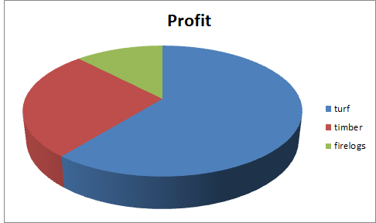

Review/Conclusion
- Overall, we got on great as a group. We worked well as a team, dividing all of the work up equally into our own strengths and never had any issues. We could always communicate with each other through a 'WhatsApp' group we created at the start of the project and this really brought the project along swiftly as we constantly talked about our ideas as a team.
- Other than a few difficulties such as a place to sell/source/cutting the timber etc., we had no difficulties while working as a team. We're all good friends and this really made it easy to work together.
- There were no conflicts between any of our customers with the project or with among ourselves so we had no conflicts to overcome.
- We developed countless new skills from this new venture. I myself really developed new skills that I never knew I possessed. One of these skills is Initiative. Whenever something needed to be done , such as getting turf/timber/fire logs ready to sell at the weekend we would fill the bags. Furthermore, we did work which we didn't necessarily 'have to do', however we chose to do, without being told to do it by our teacher. Another skill we developed was our marketing skills when trying to sell the product. It made us much more confident when talking to potential customers trying to make a sell. Another skill we developed was promoting. We really developed our I.T skills when doing this area of the project. Finally, we developed our teamwork skills by working together for the good of the team. We divided the work among us evenly so we could work efficiently and quickly. We helped each other out when we needed to, asking each other for help when necessary.
- We are currently looking into possibly expanding our project and to continue selling turf/timber during the summer, as well as cutting the turf ourselves, bringing it home and footing/turning it. We will be able to sell in bigger quantities during the summer perhaps selling in trailer-loads and bigger bags, as well as continuing this method.
- The advice we were given from parents/teachers was vital throughout the project and for driving us to succeed. We all agree that the best advice we were given during the project which was constantly repeated by our Enterprise teacher. 'Don't wait to be told to do something, you have to want to work on the project yourself and want it to succeed.' This really helped us start the project very quickly with some great ideas and continued throughout.
- The advice we would give to these students is exactly what our Enterprise teacher told us 'Don't wait to be told to do something, you have to want to work on the project yourself and want it to succeed.' We would also suggest to think outside the box and try to come up with an original idea and to not give up on the idea straight away even if it seems difficult to do.

